Debian 12 如何开始使用

目录
- 1 Toshiba PC notebook cannot boot due to incorrect BIOS setting
  - 1.1 How to get to the BIOS setup in Toshiba
- 2 Boot from USB
- 3 Setup Wifi is different
- 4 Shutdown
- 5 install anaconda
- 6 Install Quarto from Posit
  - 6.1 use quarto in Rstudio
  - 6.2 install libcurl
- 7 install emacs (or GIT)
- 8 quarto 安装shelly
  - 8.1 Windows安装
  - 8.2 Windows R包版本

Toshiba PC notebook cannot boot due to incorrect BIOS setting
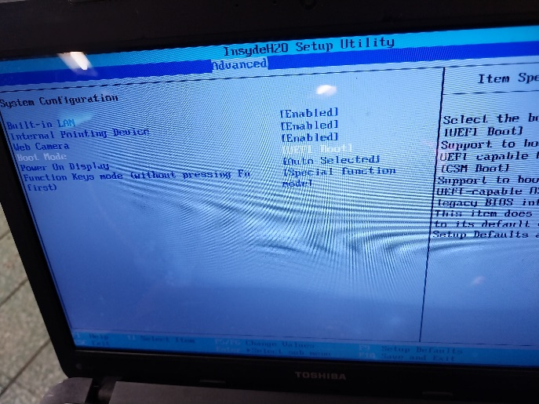
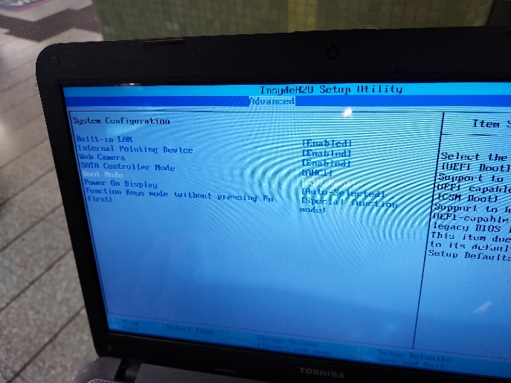
- after change the Boot Mode from UEFI to CSM
- can boot and get the boot Menu

How to get to the BIOS setup in Toshiba
- repeat press F2 key when boot
or from Win10 Setting page:
- Setting - Update & Security - Recovery - Advanced Setup "Restart Now" , then Troubleshoot - Adv Option - UEFI firmware setting

Boot from USB
- <TAB> to get one line of command from AMD64 system
- type <SPACE>persistence (USB will 'remember' all the operations)
immediately after the line
- <return> Debian12 will boot

Setup Wifi is different
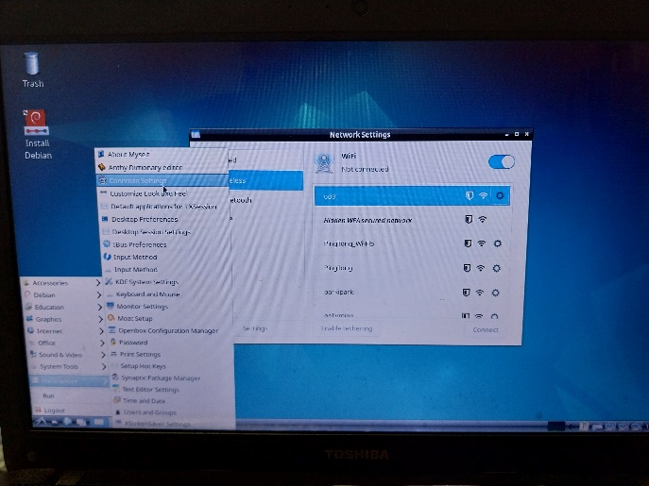
- in startup menu, click 'Preferences', then Connman Settings
- will get a double Term icon at the bottom
- click the icon to get the "Network Settings" window
- select the correct WiFi , Auto , apply , manually type the password to connect WiFi

Shutdown
- same as in Debian10 , but will show a warning first , then shutdown

install anaconda
https://www.debugpoint.com/install-anaconda-ubuntu-debian/

Install Quarto from Posit
- Download and install Quarto using .deb file
sudo curl -LO https://quarto.org/download/latest/quarto-linux-amd64.deb
Install Quarto by running (you may need to install gdebi first):
sudo apt-get install gdebi-core (optional, only if gdebi not installed)
sudo gdebi quarto-linux-amd64.deb
也可以去POSIT 官网 看如何 Install Quarto:
docs.posit.co/resources/install-quarto/
Verify Quarto installation
/usr/local/bin/quarto check
- successful, installed 1.4.551
- checked: Python 3 , Jupyter , R plus knitr, rmarkdown

use quarto in Rstudio
quarto.org/docs/get-started/hello/rstudio.html
quarto.org/docs/get-started/hello/rstudio.html

install libcurl
- Update the package index:
- sudo apt-get update
- Install libcurl4-openssl-dev deb package:
- sudo apt-get install libcurl4-openssl-dev

install emacs (or GIT)
$sudo apt update
$sudo apt install emacs (or git)
$git --version (to validate install ok)

quarto 安装shelly

Windows安装
官网下载后 正常安装后打开rstudio ,即可新建.qmd文件，也可点击render运行网页

Windows R包版本
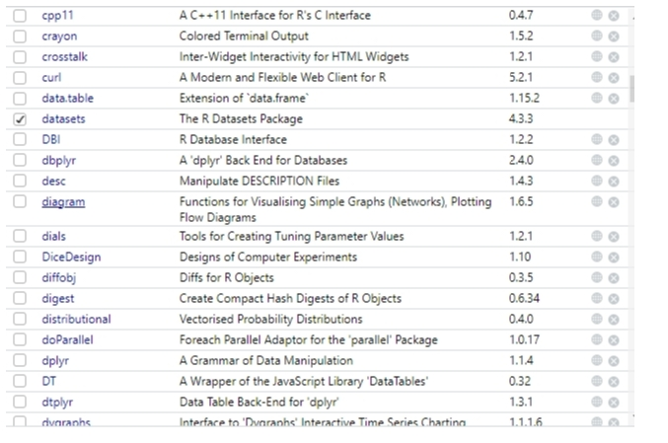
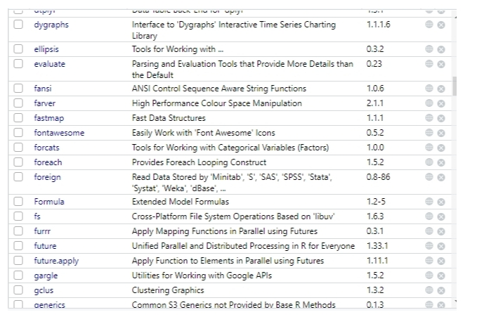
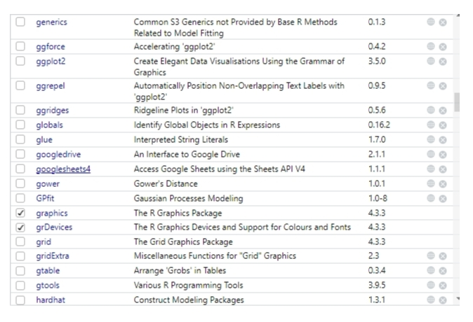
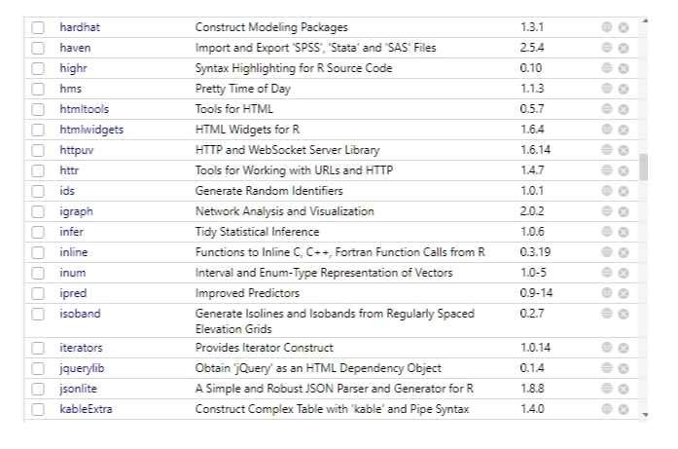
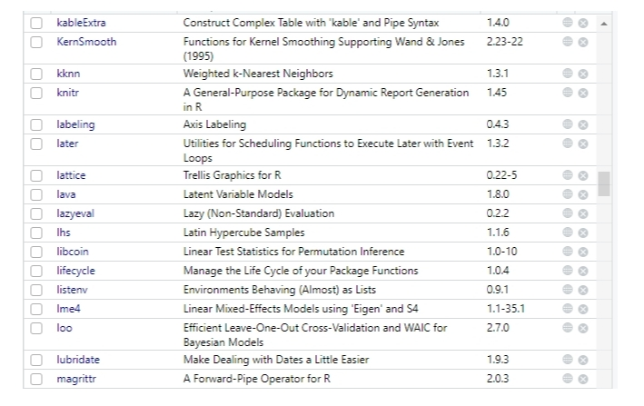
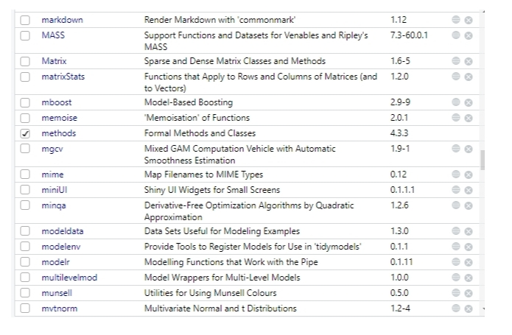
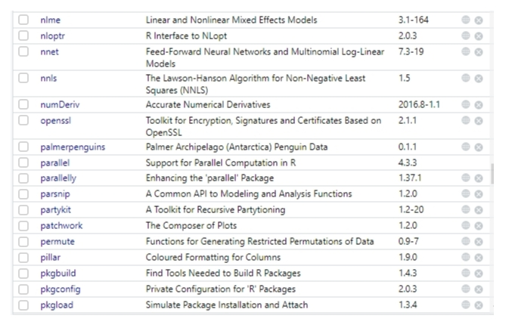
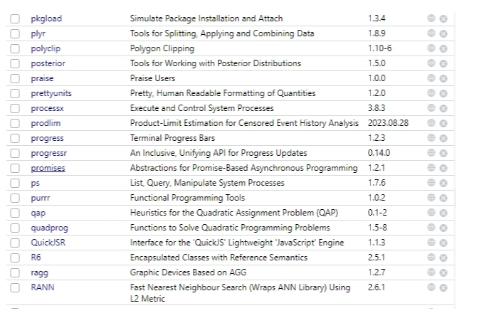
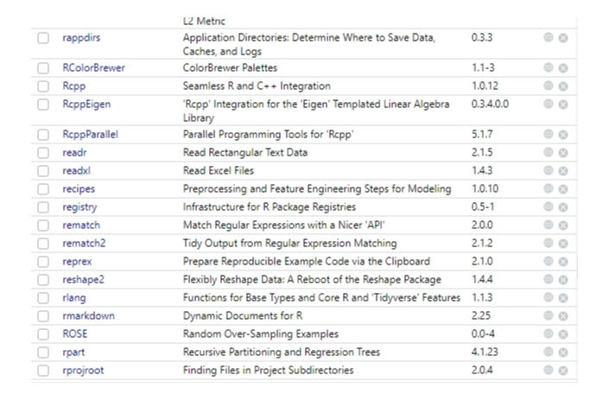
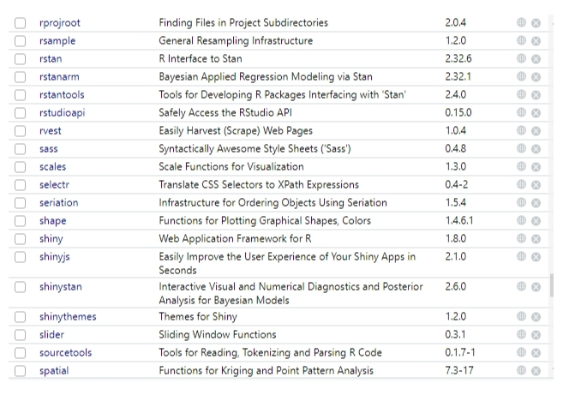
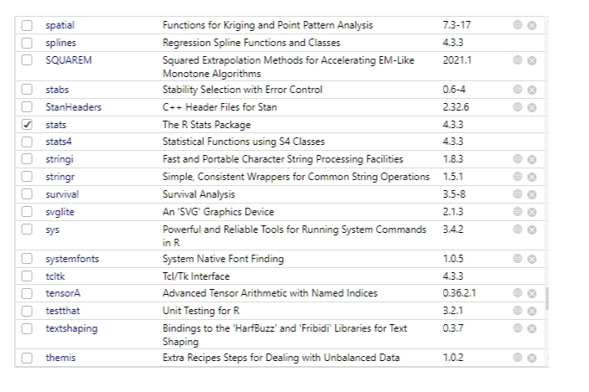
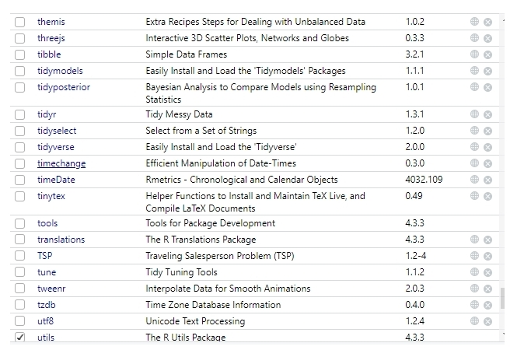
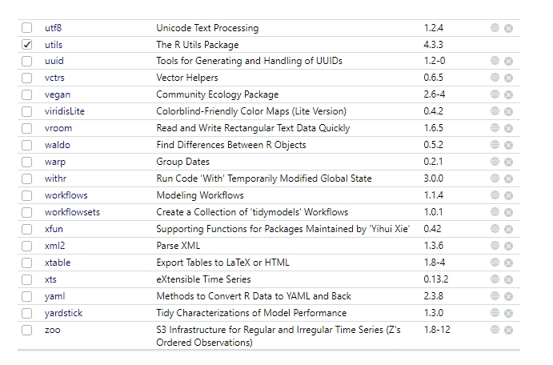
---===<<< END >>>===---

